**[Configure a Firewall in Linux](https://cybercademy.org/configure-a-firewall-in-linux-project-overview/)**

**Introduction**

This document serves to outline the implementation and importance of firewall systems in securing network infrastructures. It provides comprehensive information for IT professionals and stakeholders involved in network security.

**Firewall Systems**

A firewall is a network security system designed to monitor and control incoming and outgoing network traffic based on predetermined security rules. It acts as a barrier between a trusted internal network (such as a company's private network) and untrusted external networks (like the internet). The primary function of a firewall is to prevent unauthorized access to or from private networks while allowing legitimate communication to pass through.

Mainly there are two types of firewalls

1.Hardware firewall

2.Software firewall

**Hardware firewall**

Hardware firewall is positioned between the network and devices, allowing traffic to funnel through the firewall for a close inspection and analysis. A hardware firewall, a term often interchangeable with network or next-generation firewall, protects the network gateways for an enterprise.

Hardware firewall is physical hardware, installed between network elements and connected devices, and is tasked with filtering traffic for cyber threat to the network or devices. Filtering out unauthorized or suspicious users based on traffic analysis is one of the biggest benefits of hardware firewall.

Hardware firewall is most often used by enterprises that need a higher level of security for all users and devices, and for safe connection to vital company data in any environment. Some enterprises choose this route because they have highly skilled IT experts on their staff to manage the firewall and hardware, and those businesses who require more granular control.

**Software firewall**

Software firewall is a firewall that is installed on a computer or server, and tasked with network security. It works with a wide variety of other technology security solutions to provide more robust and cohesive security for enterprises of all sizes.

When a software firewall is installed on a server, it opens up like an umbrella of protection over all other computers connected to the network. It is able to monitor both incoming and outgoing traffic for potential risk or suspicious user behaviour, and also makes setting security policies much easier, faster and more flexible.

This type of firewall is fast becoming in the solution of choice for many reasons. Enterprises love the lower initial cost with few restrictions on the number of devices to be protected. This type of firewall is also critical as it requires very little space (as a computer program), and can be installed remotely on any number of devices. It’s far different from its counterpart, the hardware firewall, which has many unique elements in its own right.

**Types of Firewalls**

1. **Packet Filtering Firewall:**
   * **Description:** Examines packets of data as they pass through the firewall and filters them based on predetermined criteria such as source/destination IP addresses, port numbers, and protocols.
   * **Operation:** It operates at the network layer (Layer 3) of the OSI model and makes filtering decisions based on the information in the packet header.
   * **Advantages:** Simple and efficient for basic filtering tasks. It can handle large amounts of traffic without significant performance impact.
   * **Limitations:** Limited ability to inspect packet contents beyond the header information, making it susceptible to certain types of attacks like IP spoofing.
2. **Stateful Inspection Firewall:**
   * **Description:** Tracks the state of active network connections and determines whether incoming packets are allowed or denied based on the connection state.
   * **Operation:** It operates at the network layer (Layer 3) and transport layer (Layer 4) of the OSI model. It keeps a record of established connections and allows only packets that are part of these connections.
   * **Advantages:** Provides better security than packet filtering firewalls by considering the context of each connection (stateful context). Offers protection against various types of attacks, including spoofing attacks.
   * **Limitations:** Can be resource-intensive in environments with high traffic volumes. May require more processing power and memory compared to packet filtering firewalls.
3. **Proxy Firewall:**
   * **Description:** Acts as an intermediary between internal and external networks. It intercepts and handles communication requests from clients on behalf of the clients.
   * **Operation:** It operates at the application layer (Layer 7) of the OSI model, allowing it to inspect and filter traffic at a very granular level, including application-layer data.
   * **Advantages:** Provides high security by hiding internal network details and actively inspecting traffic at the application layer. Can implement deep content filtering and caching for improved performance.
   * **Limitations:** May introduce latency due to the additional processing required for each connection. Can be complex to configure and maintain compared to other firewall types.
4. **Next-Generation Firewall (NGFW):**
   * **Description:** Integrates traditional firewall capabilities with advanced security features such as deep packet inspection (DPI), intrusion prevention systems (IPS), and application awareness/control.
   * **Operation:** NGFWs operate at multiple layers of the OSI model, including layers 3 to 7, allowing them to inspect and filter traffic based on application-level data as well as traditional criteria like IP addresses and port numbers.
   * **Advantages:** Offers enhanced security by combining multiple security functions into a single device. Provides visibility into application traffic and the ability to enforce granular security policies.
   * **Limitations:** Higher cost and complexity compared to traditional firewalls. Requires careful configuration and tuning to balance security and performance.

**Choosing the Right Firewall**

* **Considerations:** When selecting a firewall type, consider factors such as the organization's security requirements, network architecture, performance needs, and budget.
* **Deployment:** Firewalls can be deployed at the network perimeter, between internal network segments (e.g., DMZ), or within individual hosts as software firewalls.
* **Integration:** Many organizations use a combination of firewall types and other security measures (e.g., intrusion detection/prevention systems, VPNs) to create a layered defense strategy.

**Terminology**

* **Network:** A collection of interconnected devices, such as computers, printers, and servers, that can communicate with each other.
* **Node:** Any device connected to a network, such as a computer, printer, or router.
* **Protocol:** A set of rules and standards that define how devices on a network communicate with each other.
* **IP Address:** A unique numerical identifier assigned to each device on a network, used to identify and communicate with other devices.
* **Router:** A networking device that connects multiple networks together and forwards data packets between them.
* **Switch:** A networking device that connects devices on a network and forwards data packets between them.
* **Firewall:** A security device or software that monitors and controls incoming and outgoing network traffic, based on a set of predefined security rules.
* **DNS (Domain Name System):** A system that translates domain names (such as www.example.com) into IP addresses, allowing devices to locate and connect to websites and other network resources.
* **LAN (Local Area Network):** A network that connects devices within a limited geographical area, such as a home, office, or building.
* **WAN (Wide Area Network):** A network that connects devices over a large geographical area, such as multiple offices in different cities or countries.
* **DHCP (Dynamic Host Configuration Protocol):** A protocol that automatically assigns IP addresses and network configuration settings to devices on a network.
* **TCP/IP (Transmission Control Protocol/Internet Protocol):** A set of protocols used to communicate over the internet and other networks.

**Importance of Terminology:**

* **Facilitates Communication:**
  + Enables clear and efficient communication among professionals, researchers, practitioners, and stakeholders within a specific field or discipline.
* **Enhances Understanding:**
  + Helps individuals grasp complex concepts and ideas more easily by providing a standardized vocabulary that conveys precise meanings.
* **Supports Knowledge Sharing:**
  + Promotes the dissemination of knowledge and information within the field, ensuring that insights and discoveries are accurately communicated and understood.
* **Promotes Consistency and Accuracy:**
  + Ensures consistency in documentation, publications, research, and technical documentation, which is critical for maintaining quality and reliability.
* **Aids Education and Training:**
  + Forms the basis for education and training programs within the field, providing students and professionals with the necessary terminology to develop expertise and proficiency.

**1. IP Address (Internet Protocol Address)**

* **Definition:** An IP address is a numerical label assigned to each device connected to a computer network that uses the Internet Protocol for communication.
* **Functions:**
  + **Identification:** It uniquely identifies a device on a network, similar to how a street address identifies a house.
  + **Location Addressing:** It provides the location of a device in a network hierarchy.
* **Types:**
  + **IPv4:** Uses a 32-bit address expressed in dotted-decimal format (e.g., 192.168.0.1).
  + **IPv6:** Uses a 128-bit address to accommodate the growing number of devices connected to the internet.
* **Example:** An IP address allows devices like computers, smartphones, and servers to communicate with each other across the internet or within a private network.

**2. LAN (Local Area Network)**

* **Definition:** A LAN is a network that spans a relatively small area, such as a single building or a campus. It connects computers, servers, printers, and other devices.
* **Characteristics:**
  + **High-Speed Data Transfer:** LANs typically offer high-speed data transfer rates.
  + **Private:** LANs are private networks owned and managed by an organization.
  + **Ethernet:** Commonly used LAN technology, connecting devices through Ethernet cables or wireless connections (Wi-Fi).
* **Example:** LANs are commonly used in homes, schools, and businesses to facilitate local communication and resource sharing.

**3. WAN (Wide Area Network)**

* **Definition:** A WAN is a network that covers a larger geographic area and connects multiple LANs or other WANs together.
* **Characteristics:**
  + **Long-Distance Communication:** WANs enable long-distance communication between geographically dispersed locations.
  + **Public and Private Infrastructure:** WANs can utilize public infrastructure (like the internet) or private networks (leased lines or MPLS).
  + **Lower Data Transfer Rates:** Generally, WANs have lower data transfer rates compared to LANs due to the longer distances involved.
* **Example:** The internet itself is a vast WAN that connects millions of devices worldwide.

**4. Internet Traffic Types**

Network traffic is the amount of data moving across a computer network at any given time. Network traffic, also called data traffic, is broken down into data packets and sent over a network before being reassembled by the receiving device or computer.

**Data Traffic:**

* Unicast: Data sent from one device to another single device. This is the most common type of traffic on networks.
* Multicast: Data sent from one device to multiple specified devices.
* Broadcast: Data sent from one device to all devices on the network segment. Broadcasts can create network congestion and are generally limited in use.

**Control Traffic:**

* Routing Updates: Information exchanged between routers to maintain the correct paths for data transmission across the network.
* Address Resolution Protocol (ARP): Used to map IP addresses to MAC addresses in local networks.

**Management Traffic:**

* SNMP (Simple Network Management Protocol): Used by network administrators to monitor and manage network devices.
* Syslog: Used for collecting and storing log messages from network devices.

**Voice and Video Traffic:**

* VoIP (Voice over Internet Protocol): Transmission of voice communications over IP networks.
* Video Streaming: Transmission of video content over IP networks, which requires high bandwidth and low latency.

**Web Traffic:**

* HTTP (Hypertext Transfer Protocol): Used for transmitting web pages and other content on the World Wide Web.
* HTTPS (Hypertext Transfer Protocol Secure): Secure version of HTTP, encrypted for secure transactions.

**Email Traffic:**

* SMTP (Simple Mail Transfer Protocol): Used for sending email messages between servers.
* POP3 (Post Office Protocol version 3) and IMAP (Internet Message Access Protocol): Used for retrieving email messages from servers.

**File Transfer Traffic:**

* FTP (File Transfer Protocol): Used for transferring files between hosts on a network.
* SFTP (SSH File Transfer Protocol): Secure version of FTP, encrypted for secure file transfers.

**5. IP Header (Internet Protocol Header)**

* **Definition:** The IP header is part of an IP datagram (packet) and contains essential information for routing and delivering packets across networks.
* **Components:**
  + **Source and Destination IP Addresses:** Identify the sending and receiving devices.
  + **Packet Length:** Indicates the total length of the packet.
  + **Protocol Version:** Specifies the version of the IP protocol (IPv4 or IPv6).
* **Function:** The IP header allows routers and other network devices to correctly route and deliver packets to their destinations based on the IP addresses and other information contained within the header.

**6. TCP Header (Transmission Control Protocol Header)**

* **Definition:** The TCP header is used in conjunction with IP to ensure reliable transmission of data across networks.
* **Components:**
  + **Source and Destination Port Numbers:** Identify the sending and receiving applications on devices.
  + **Sequence and Acknowledgment Numbers:** Ensure ordered delivery and acknowledge receipt of data segments.
  + **Control Flags:** Manage the connection (e.g., establishing, maintaining, and terminating connections).
* **Function:** The TCP header provides mechanisms for flow control, error detection, and reliable data transfer between applications running on devices connected via TCP/IP networks.

**Development and Testing**

**Development Steps**

1. **Understand Requirements and Network Architecture**:
   * Identify which chains (INPUT, OUTPUT, FORWARD) need rules based on your system's role (e.g., server, router).
   * Determine default policies (ACCEPT or DROP) for each chain based on security needs.
2. **Initial Configuration**:
   * Install or update iptables if necessary:

bash

Copy code

sudo apt-get install iptables

1. **Define Default Policies**:
   * Set default behavior for unmatched traffic in each chain:

bash

Copy code

sudo iptables --policy INPUT ACCEPT

sudo iptables --policy OUTPUT ACCEPT

sudo iptables --policy FORWARD ACCEPT

* + Optionally, set policies to DROP if you prefer a default deny strategy.

1. **Adding Specific Rules**:
   * Begin by allowing essential services like SSH:

bash

Copy code

sudo iptables -A INPUT -p tcp --dport ssh -j ACCEPT

sudo iptables -A OUTPUT -p tcp --sport ssh -j ACCEPT

* + Add rules to block specific IP addresses, ranges, or ports as needed:

bash

Copy code

sudo iptables -A INPUT -s 10.10.10.10 -j DROP

sudo iptables -A INPUT -s 10.10.10.0/24 -j DROP

sudo iptables -A INPUT -p tcp --dport ssh -j DROP

1. **Test Rules**:
   * Ensure rules are applied correctly by checking the current iptables configuration:

bash

Copy code

sudo iptables -L -n -v

* + Verify that rules match expected behavior for incoming and outgoing connections.

1. **Implement Connection States**:
   * Handle two-way communication for protocols like SSH:

bash

Copy code

sudo iptables -A INPUT -p tcp --dport ssh -m state --state NEW,ESTABLISHED -j ACCEPT

sudo iptables -A OUTPUT -p tcp --sport ssh -m state --state ESTABLISHED -j ACCEPT

**Testing Steps**

1. **Simulate Network Traffic**:
   * Use tools like ping, ssh, or other network utilities to simulate connections that should be allowed or blocked based on your rules.
2. **Verify Rule Effectiveness**:
   * After simulating traffic, check iptables logs or use verbose (-v) mode to view packet and byte counts for each rule:

bash

Copy code

sudo iptables -L -v

1. **Test Edge Cases**:
   * Verify handling of unexpected or malformed traffic to ensure iptables behaves as expected.
2. **Validation and Documentation**:
   * Document your configured rules, policies, and their rationale in your network security policy document.
   * Ensure documentation is clear and accessible to other administrators or team members.
3. **Save Configuration**:
   * Persist iptables rules across reboots by saving the configuration:
     + **Ubuntu**:

bash

Copy code

sudo /sbin/iptables-save > /etc/iptables/rules.v4

* + - **Red Hat / CentOS**:

bash

Copy code

sudo /sbin/service iptables save

1. **Monitor and Maintain**:
   * Regularly monitor iptables logs and network traffic patterns to ensure ongoing security and performance.

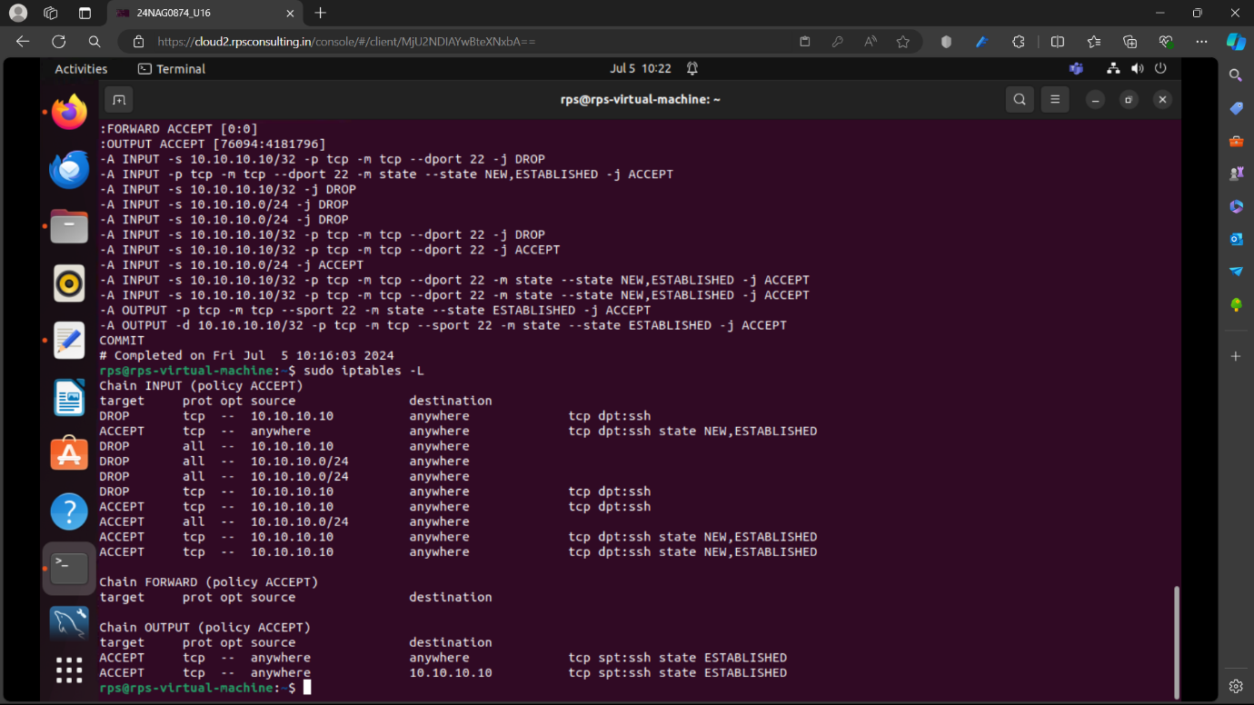

**Conclusion**

Implementing and managing iptables as a firewall utility on Linux systems is crucial for securing network traffic and controlling access to services. Throughout this project, we have covered fundamental concepts, configuration steps, and best practices to effectively utilize iptables.

Key Learnings:

* **iptables Basics:**

Understanding the three main chains: INPUT, OUTPUT, and FORWARD.

Default policies (ACCEPT vs DROP) and their implications on network security.

* **Configuration Steps:**

Installing or updating iptables using package managers.

Setting default policies and adding specific rules to allow or block traffic based on IP addresses, ports, and protocols.

Utilizing connection states (NEW, ESTABLISHED, RELATED) to manage two-way communication effectively.

* **Testing and Validation:**

Simulating network traffic to validate iptables rules.

Monitoring and verifying rule effectiveness using iptables -L -v and other diagnostic commands.

Documenting rules and configurations to maintain clarity and facilitate collaboration among team members.

* **Security Considerations:**

Importance of cautious rule configuration to avoid unintended network disruptions or security vulnerabilities.

Safeguarding SSH access and other critical services by appropriately configuring iptables rules.

* **Maintenance and Monitoring:**

Saving iptables configurations to persist across system reboots (iptables-save for Ubuntu, service iptables save for Red Hat/CentOS).

Regularly reviewing and updating rules based on evolving security requirements and network conditions.

Monitoring network traffic patterns and iptables logs to detect and respond to potential security incidents.

**Future Considerations**

Advanced Rule Management: Explore iptables capabilities for advanced scenarios such as Network Address Translation (NAT), packet filtering, and more complex routing configurations.

Automation and Scripting: Implement automation tools or scripts (e.g., using iptables-restore and iptables-save) to streamline rule deployment and management processes.

Integration with Security Frameworks: Consider integrating iptables configurations with broader security frameworks or tools to enhance network security posture.